Step-by-Step Instructions: Sharing Your AI Chat Conversation
  - A Student Guide to Posting and Documenting Your AI Learning Experience

Step 1: Copy the Prompt
Copy the following prompt, which sets clear expectations for your AI assistant. This prompt asks the AI to guide your thinking, ask questions, and explain concepts without giving direct answers:
I am working on a multiple linear regression project using a small health-related dataset with three variables: sleep, caffeine, and stress. Act as my thinking partner. Do not give me full answers or report-ready text. Instead, guide me step by step, and after each step, ask me one clarifying or reflective question before moving on. Explain why each step matters and what ideas I should consider when making decisions. Use general examples if needed, but do not use my dataset values or provide final interpretations.

Help me understand the process by asking questions like:
What does this coefficient mean in context?
How would I explain R squared to someone with no statistics background?
Why might these predictors be related?
What assumptions should I check?
What limitations might I need to note?

Your role is to support my reasoning and help me understand how to build and interpret the model gradually, not to create my report content.

Step 2: Open Your Chosen Gen AI Tool
- Go to the platform you want to use: ChatGPT (chat.openai.com), Gemini (gemini.google.com), or Copilot (copilot.microsoft.com).
- Log in with your account if you have one.

Step 3: Start the Conversation
- Paste the prepared prompt into the chat input box.
- Send the prompt to begin the conversation.
The AI will respond according to your instructions, such as posing guiding questions, explaining concepts, and helping you reason through your project without giving direct answers.

Step 4: Engage in the Chat
- Respond to the AI’s questions and prompts about your project.
- Ask for clarifications and additional explanations as needed.
- Continue the dialogue until you feel your understanding has grown or you have addressed your project needs.
Remember, the AI should not provide specific answers or write your report, but support your reasoning and learning process.

Step 5: Save the Conversation
- Upon completion, select the ellipsis menu (the three dots) located beside this Chat conversation.
- Click “Share” to obtain the share link.
Where to find the SHARE button in different AI tools
ChatGPT | 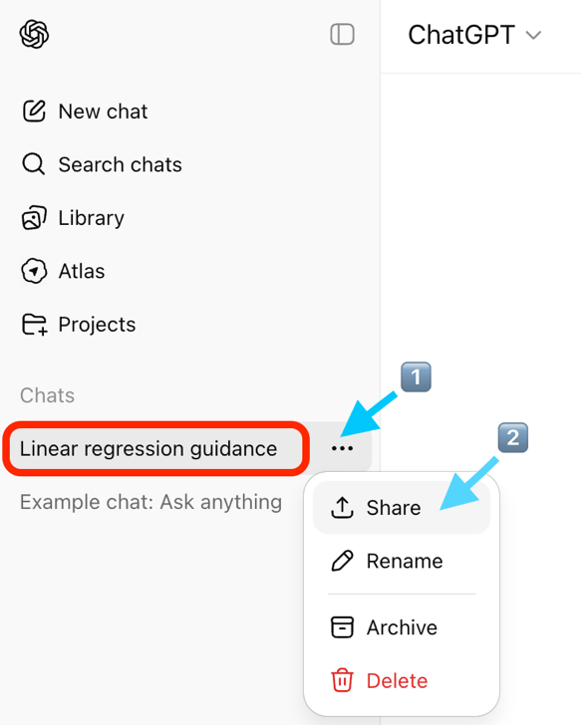
Gemini | 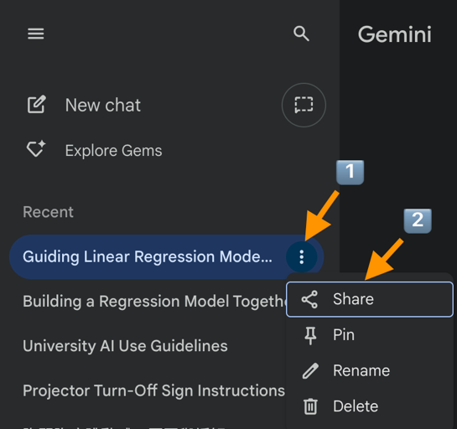
Copilot | 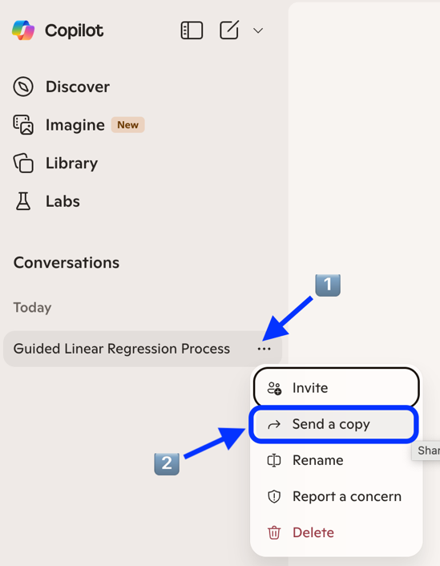

- Click the copy icon below the last conversation.
- Paste the conversation into a Word document.

Step 6: Paste the Link at the End of Your Report

